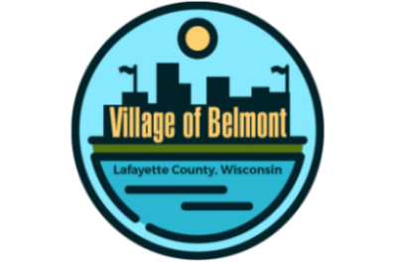
Village of Belmont
222 S. Mound Ave., Belmont, WI
REGULAR BOARD MEETING
in the Community Building

WEDNESDAY, AUGUST 16, 2023 @ 7 PM
AGENDA

- CALL TO ORDER
- PLEDGE OF ALLEGIANCE
- ROLL CALL
- VERIFICATION OF PROPER NOTICE
- CONSIDERATION OF CONSENT CALENDAR
(The following items may be approved on a single motion & vote due to their routine nature. Please indicate to the Village President if you would prefer separate discussion & action.)
- Approve Agenda
- Approve Minutes of Previous Meeting(s)
- Clerk-Treasurer’s Financial Reports
- Approval of Invoices to Pay
- CITIZEN’S COMMENTS, OBSERVATIONS AND PETITIONS, if any
- VILLAGE OFFICIAL’S REPORTS
- President
- Police Department
- Engineering Consultant, Dan Dreessens, Delta 3 Engineering
- Director of Public Works
- Clerk-Treasurer
f. Trustee(s):
- COMMITTEE & COMMISSION MEETING REPORT(S)
a. Belmont Fire/EMS District Meeting – August 9, 2023
b. Tourism Commission Meeting – August 15, 2023
c. Park & Buildings Meeting – August 16, 2023
- OLD BUSINESS
- NEW BUSINESS
- Discussion and or Action
1. Action if any, on Fair Tractor Pull on Liberty Street for the School Fair,
September 17, 2023.
2. Action if any, on Belmont Fire/EMS District Meeting.
3. Action if any, on Tourism Commission Meeting.
4. Action if any, Park & Buildings Meeting.
B. Information of Upcoming Discussion and/or Action Items and Meetings
- ADJOURNMENT
Julie Abing, Clerk-Treasurer
Posted: Tuesday, August 15, 2023

Please note that, upon reasonable notice, efforts will be made to accommodate the needs of disabled individuals through.
appropriate aids and services. For additional information or to request this service, contact the Village Office by calling 762-5142.
Posted at: Belmont Post Office, Mound City Bank, Community Building, Message Center around corner from Village Office Door.

