Village of Belmont
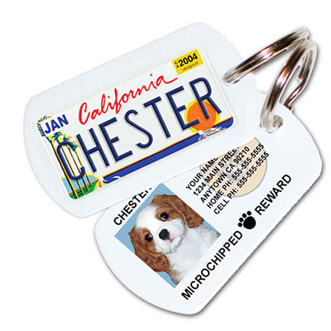
Dog License Application

222 S. Mound Ave.
P.O. Box 6
Belmont, WI 53510
Email: jabing@vi.belmont.wi.gov

~ The Village requires all dogs, 5 months or older, to be licensed every year & to have a current rabies certificate on file with the Village Office.
~ Dogs are regulated by Wisconsin State Statutes 174.05-174.10 & Section #9.09 of the Village of Belmont Municipal Code.
~ Licenses are valid January 1st thru December 31st of each year.

Proof of Valid Rabies: State Law and Village Ordinance requires that your animal has a current rabies vaccination. We will need to see the Rabies Certificate from your vet showing proof of the rabies vaccine along with the expiration date. Rabie tags are NOT proof of rabies vaccination.

Accepted Forms of Payment: Cash, Checks, debit, and credit card payments are acceptable. Please make all checks payable to: Village of Belmont. If paying by debit or with credit card, please visit www.PaymentServiceNetwork.com. Please enclose a copy of your receipt for proof of payment along with this form. Dog tag will not be issued unless proof of rabies has also been provided. DO NOT INCLUDE YOUR DOG LICENSE FEE WITH YOUR PROPERTY TAX PAYMENT. SEPARATE CHECKS ARE REQUIRED.

Fee: If spayed/neutered cost is $3.00 per animal. If not spayed/neutered cost is $8.00 per animal. A $5.00 late fee per animal will be implemented after March 31st for renewal applicants only.

Self-Addressed Stamp Envelope: If you would like us to mail you the dog tag, please include a self-addressed stamped envelope.

******************************************************************************************************************************************************************
Customer Information

Name of Pet Owner(s): ______________________________________________________________________________________________

Address where pet resides: ______________________________________________________________City: Belmont, State: WI Zip: 53510

Phone Number: _______________________________________ Email: _______________________________________________________

Animal Information

License Type: New Animal Renewal

Animal Name: ____________________________Breed: ______________________________ Color: ________________________________

Fee: Male Neutered- $3 Male Intact - $8 Female Spayed - $3 Female Intact - $8 Late Fee ($5 If after March 31st)

Vet: ___________________________________Rabies Lot # _____________________________ Expiration Date: _____________________
License Type: New Animal Renewal

Animal Name: ____________________________Breed: ______________________________ Color: ________________________________

Fee: Male Neutered- $3 Male Intact - $8 Female Spayed - $3 Female Intact - $8 Late Fee ($5 If after March 31st)

Vet: ___________________________________Rabies Lot # _____________________________ Expiration Date: _____________________

License Type: New Animal Renewal

Animal Name: ____________________________Breed: ______________________________ Color: ________________________________

Fee: Male Neutered- $3 Male Intact - $8 Female Spayed - $3 Female Intact - $8 Late Fee ($5 If after March 31st)

Vet: ___________________________________Rabies Lot # _____________________________ Expiration Date: _____________________

